Q. What are benefits of RCC?  - Students learn the basic elements and need for national security and their personal obligations as Americans.  - The program enhances the image of the military in the eyes of the community by providing a chance for success to the nation's youth.  - While the training is along military lines, it is conducted to encourage initiative and individuality to develop natural gifts, to teach self-control, develop personal character, responsibility and qualities of integrity, loyalty, and dedication.  - Cadets derive self-esteem from belonging to RCC.  - Cadets successfully completing at least 3 years are entitled to advanced promotion to pay grade E-3 upon initial enlistment in an active or reserve component of the Navy, or Air Force, and pay grade E-2 in the Army or the Marine Corps.  - Cadets successfully completing 2 years are entitled to be enlisted in the Navy in pay grade E-2.  - Senior Naval Science Instructor is authorized to nominate a maximum of three eligible cadets each year to compete for U.S. Naval Academy appointments.  - Administrators of Distinguished Units with Academic Honors may nominate three eligible cadets as candidates for appointment to the U.S. Naval, Air Force and Military, Academies. | Who We Are  About Us  RCC is managed by retired military personnel who are certified by the Naval Service Training Command to administer the Navy-approved curriculum. Our vision is to help prepare cadets to be either career, college, or military ready to be viable citizens contributing to a community.  Contact Us  Phone: 919-554-6303  Email: knilles@wcpss.net, pperry@wcpss.net  Rolesville cadet corps  1099 East Young Street  Rolesville, NC 27571 |   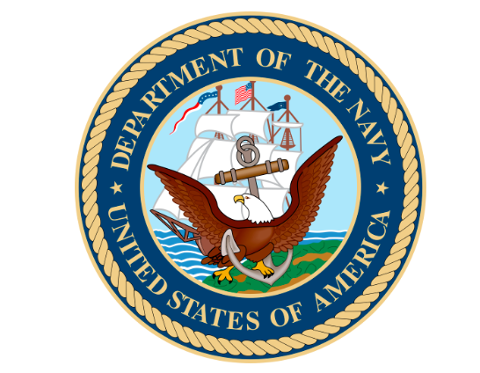  ROLESVILLE’S NAVY NATIONAL DEFENSE CADET CORPS
Rolesville’s Cadet Corps (RCC) Program provides a course of instruction in military training, prescribed by the Navy, and modeled after the Navy Junior Reserve Officer Training Corps (NJROTC) Program. The RCC Program expands student opportunities to learn the values of citizenship and leadership, service to the United States, and personal responsibility and to attain a sense of accomplishment. Completion of the program DOES NOT incur military obligation.  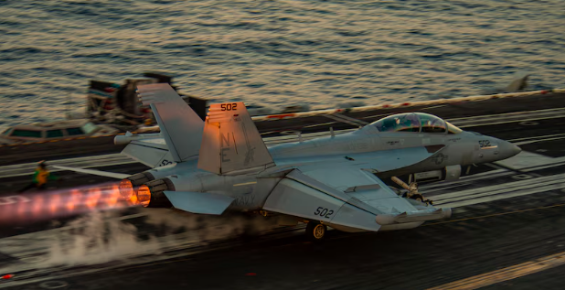   | Q. What are the student enrollment eligibility requirements?  - Be enrolled in and attending a regular course of instruction in grade 9 through 12 of a host school.  - Be above 14 years of age.  - Be physically qualified to participate in Rolesville’s physical education program and in all RCC activities.  - Be selected by the RCC instructor with the approval of the school principal or his/her representative.  - Maintain acceptable standards of academic achievement and an academic standing that warrants at least normal progression leading to graduation.  - Maintain acceptable standards of conduct.  - Comply with specified personal grooming standards. Common sense and good judgment apply to the attainment of these standards. Standards will not be relaxed so as to reflect disgrace on the naval service. | Q. What subjects are included in the curriculum?  CITIZENSHIP  NAVAL ORIENTATION  NAVAL OPERATIONS/ORGANIZATION  NAVAL HISTORY  NAVIGATION  SEAMANSHIP  LEADERSHIP  NAUTICAL ASTRONOMY  ELECTRONICS  OCEANOGRAPHY  DRILLS, COMMANDS, AND CEREMONIES  